ASSIGMENT I

CODE:
#include <stdio.h>
#include <string.h>

#define SIZE 5

int id[SIZE];
char location[SIZE][30];
char timestamp[SIZE][30];
float temperature[SIZE];
float humidity[SIZE];

int f = 0, r = -1, count = 0;

void enqueue()
{
if (count == SIZE)
{
printf("Queue is Full!\n");
return;
}

r++;
if (r == SIZE)
r = 0;

printf("Enter Observation ID: ");
scanf("%d", &id[r]);

printf("Enter Location: ");
scanf("%29s", location[r]);

printf("Enter Timestamp: ");
scanf("%29s", timestamp[r]);

printf("Enter Temperature: ");
scanf("%f", &temperature[r]);

printf("Enter Humidity: ");
scanf("%f", &humidity[r]);

count++;
printf("Observation added successfully!\n");
}

void dequeue()
{
if (count == 0)
{
printf("Queue is Empty!\n");
return;
}

printf("Removed Observation ID: %d\n", id[f]);

f++;
if (f == SIZE)
f= 0;

count--;
}

void peek()
{
if (count == 0)
{
printf("Queue is Empty!\n");
return;
}

printf("Observation ID: %d\n", id[f]);
printf("Location: %s\n", location[f]);
printf("Timestamp: %s\n", timestamp[f]);
printf("Temperature: %.2f\n", temperature[f]);
printf("Humidity: %.2f\n", humidity[f]);
}

void display()
{
int i, j;

if (count == 0)
{
printf("Queue is Empty!\n");
return;
}

printf("\n--- Weather Observations ---\n");

j = f;

for (i = 0; i < count; i++)
{
printf("\nID: %d", id[j]);
printf("\nLocation: %s", location[j]);
printf("\nTimestamp: %s", timestamp[j]);
printf("\nTemperature: %.2f", temperature[j]);
printf("\nHumidity: %.2f\n", humidity[j]);

j++;
if (j == SIZE)
j = 0;
}
}

void search()
{
int ID, i, j, found = 0;

printf("Enter Observation ID to search: ");
scanf("%d", &ID);

j = f;

for (i = 0; i < count; i++)
{
if (id[j] == ID)
{
printf("Observation Found!\n");
printf("Location: %s\n", location[j]);
printf("Timestamp: %s\n", timestamp[j]);
printf("Temperature: %.2f\n", temperature[j]);
printf("Humidity: %.2f\n", humidity[j]);
found = 1;
break;
}

j++;
if (j == SIZE)
j = 0;
}

if (found == 0)
printf("Observation Not Found!\n");
}

void queueCount()
{
printf("Total observations: %d\n", count);
}

void queueStatus()
{
if (count == 0)
printf("Queue is Empty!\n");
else if (count == SIZE)
printf("Queue is Full!\n");
else
printf("Queue is Partially Filled!\n");
}

int main()
{
int choice;

do
{
printf("\n\n--- Climate Heatwave Monitoring ---\n");
printf("1. Enqueue Observation\n");
printf("2. Dequeue Observation\n");
printf("3. Peek Observation\n");
printf("4. Display Observations\n");
printf("5. Search Observation\n");
printf("6. Count Observations\n");
printf("7. Queue Status\n");
printf("8. Exit\n");

printf("Enter your choice: ");
scanf("%d", &choice);

switch (choice)
{
case 1:
enqueue();
break;

case 2:
dequeue();
break;

case 3:
peek();
break;

case 4:
display();
break;

case 5:
search();
break;

case 6:
queueCount();
break;

case 7:
queueStatus();
break;

case 8:
printf("Program Ended.\n");
break;

default:
printf("Invalid Choice!\n");
}

} while (choice != 8);

return 0;
}

OUTPUT:
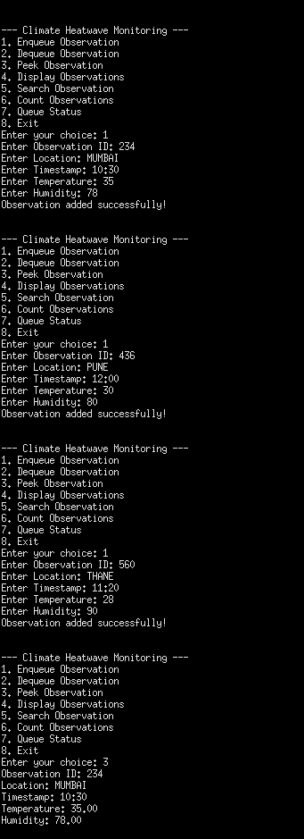
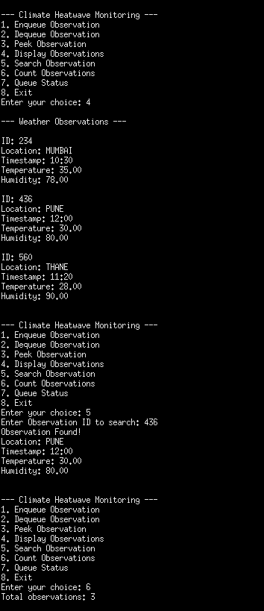
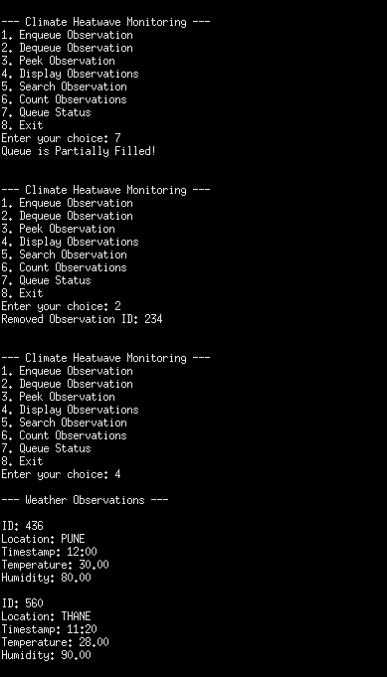

CLIMATE HEATWAVE MONITORING SYSTEM USING A CIRCULAR QUEUE

1. Basic Concept of Queue
Queue: A queue is a data structure that follows a specific order. New observations are stored at the rear, while observations are taken out from the front.
FIFO (First In, First Out): According to FIFO, the observation that enters the queue earliest will be removed before the observations added later.

2. FIFO Demonstration
The FIFO principle can be understood by inserting three weather records and removing them in the same sequence.
Step 1: Insert Weather Records
Operation Queue Contents
Insert 101 (Mumbai) 101
Insert 102 (Pune) 101 → 102
Insert 103 (Nagpur) 101 → 102 → 103
Step 2: Process Weather Records
Operation Processed Record Queue After Removal
Remove 101 (Mumbai) 102 → 103
Remove 102 (Pune) 103
Remove 103 (Nagpur) Empty
The example confirms that the first inserted observation is processed first.

3. Algorithms
A. Add Observation (Enqueue)
STEP 1: Check whether total == MAX. If true, print "Queue is Full".
STEP 2: If space is available, move rear to the next circular position using (rear + 1) % MAX.
STEP 3: Accept the observation ID, place, date and time, temperature, and humidity.
STEP 4: Increment total.
STEP 5: End.
B. Remove Observation (Dequeue)
STEP 1: Check whether total == 0. If true, print "Queue is Empty".
STEP 2: If the queue contains records, display the ID at the front.
STEP 3: Move front to its next circular position using (front + 1) % MAX.
STEP 4: Decrement total.
STEP 5: End.
C. View First Observation (Peek)
STEP 1: If total == 0, display "Queue is Empty".
STEP 2: Otherwise, show the ID, location, timestamp, temperature, and humidity of the first observation.
STEP 3: End.
D. Display All Observations
STEP 1: If total == 0, display "Queue is Empty".
STEP 2: Otherwise, set the current position to front.
STEP 3: Display the details of each observation.
STEP 4: Update the position using (pos + 1) % MAX after each record.
STEP 5: Continue until total observations have been displayed, then end.
E. Find Observation (Search)
STEP 1: Ask the user to enter an observation ID.
STEP 2: Begin checking the queue from front.
STEP 3: Compare the entered ID with each stored observation ID.
STEP 4: If the ID matches, print the corresponding weather details.
STEP 5: If the search finishes without a match, print "Observation Not Found".
STEP 6: End.
F. Display Observation Count
STEP 1: Obtain the current value of total.
STEP 2: Print the total number of records present in the queue.
STEP 3: End.
G. Check Queue Status
STEP 1: If total == 0, display "Queue is Empty".
STEP 2: If total == MAX, display "Queue is Full".
STEP 3: If neither condition is true, display "Queue is Partially Filled".
STEP 4: End.

4. Time Complexity Analysis
Time complexity represents the time needed to perform an operation as the number of observations grows. It is written using Big O notation.

Operation Time Complexity Reason
Enqueue O(1) Inserts one observation.
Dequeue O(1) Removes one observation
From the front.
Peek O(1) Accesses the first observation.
Display O(n) Traverses all observations in
the queue.
Search O(n) Checks records until a match is
found or the queue ends.
Count O(1) Uses the stored total count.
Queue Status O(1) Checks whether the queue is
empty, full, or partially filled.

5. Space Complexity Analysis
Space complexity measures the memory used by the queue and its operations.
Operation Auxiliary Space Complexity
Enqueue O(1)
Dequeue O(1)
Peek O(1)
Display O(1)
Search O(1)
Count O(1)
Queue Status O(1)

Overall Space Complexity: O(M)
M denotes the maximum number of observations that the queue can store. Since the program uses a fixed-size array of five positions, its storage requirement is proportional to the queue capacity.

